Ministry of Transportation

BITS Replatforming
(3,2) System Functional Requirements

Version 3.0

Table of Contents

Table of Contents 2
1.0 Revision_History_SFR 3
1.1 Description of the Revision_History_SFR 3
2.0 Introduction 3
2.1 Purpose 3
2.2 Scope 4
3.0 Specific Requirements 4
3.1 List of Actors 4
3.2 System Use Case Model 4
3.3 Use Case List 7
3.4 Interface to Vehicle System 8
4.0 Wireframes 9
4.1 Profile Maintenance 9
4.2 Inspection Assignment List 10
4.3 Inspection Notification and Results 10
4.4 Bulk Operation 11
5.0 Security Requirements 11
5.1 Access Control 11

Revision_History_SFR

Description of the Revision_History_SFR
Deliverable Information

Project | BITS Replatforming
Deliverable Number | BITS_RP_03
Deliverable Name | System Functional Requirements
Deliverable Lead | Masoud Hariri
Deliverable Acceptance Owner

Sr. | Deliverable | Deliverable Due Date | Deliverable Content | Response / Approval Date
1 | SFR | 18-Sep-2017 | Approval Version – V1

Revision History

Version | Date | Description | Author
0.1 | 02-Aug-2017 | Draft of the document | Masoud Hariri
1.0 | 22-Aug-2017 | Completion of V1.0 | Masoud Hariri
2.0 | 08-Sep-2017 | BITS Administration Use Case Diagram Changed | Masoud Hariri
3.0 | 15-Sep-2017 | Proposed changes by business implemented | Masoud Hariri

Introduction
A System Use Case Model describes the intended functions and environment in which a system is to be built. Each system use case is defined in a System Use Case Specification wherein it focuses on system behavior in terms of helping the end-user achieve the objectives.

Purpose
The purpose of this document is to establish the System Use Case Model and describe the System Use Case Specifications that are aligned with the MTO(CSEB & ROB) processes. The document is essential as it provides detailed information on the BITS system based on detailed business descriptions.

Scope
This document includes the models and use cases needed in delivery of BITS Replatforming project. The system use cases all belong to one use case packages, namely:

• BUS Inspection

Specific Requirements

List of Actors
Code | Name | Type | Role | Description
A_1 | District Administrator | Person/MTO-ROB | District Admin
A_2 | Enforcement Officer | Person/MTO-ROB | Enforcement Officer
A_3 | Bus Program Administrator | Person/MTO-CSEB | System Admin
A_4 | Vehicle System (LCS) | System | N/A

Release 2: Package Model

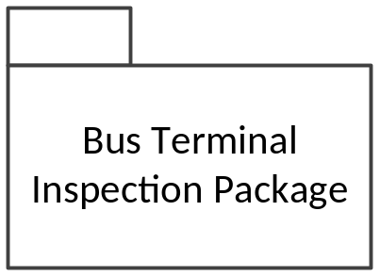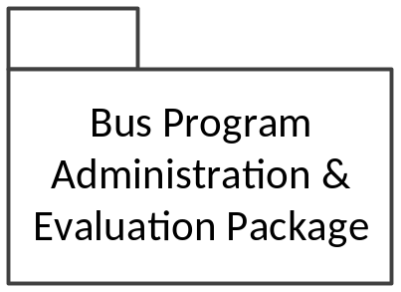

System Use Case Model
Following diagram shows 16 high level solution layer system use cases for the above 2 packages:

Bus Terminal Inspection Model
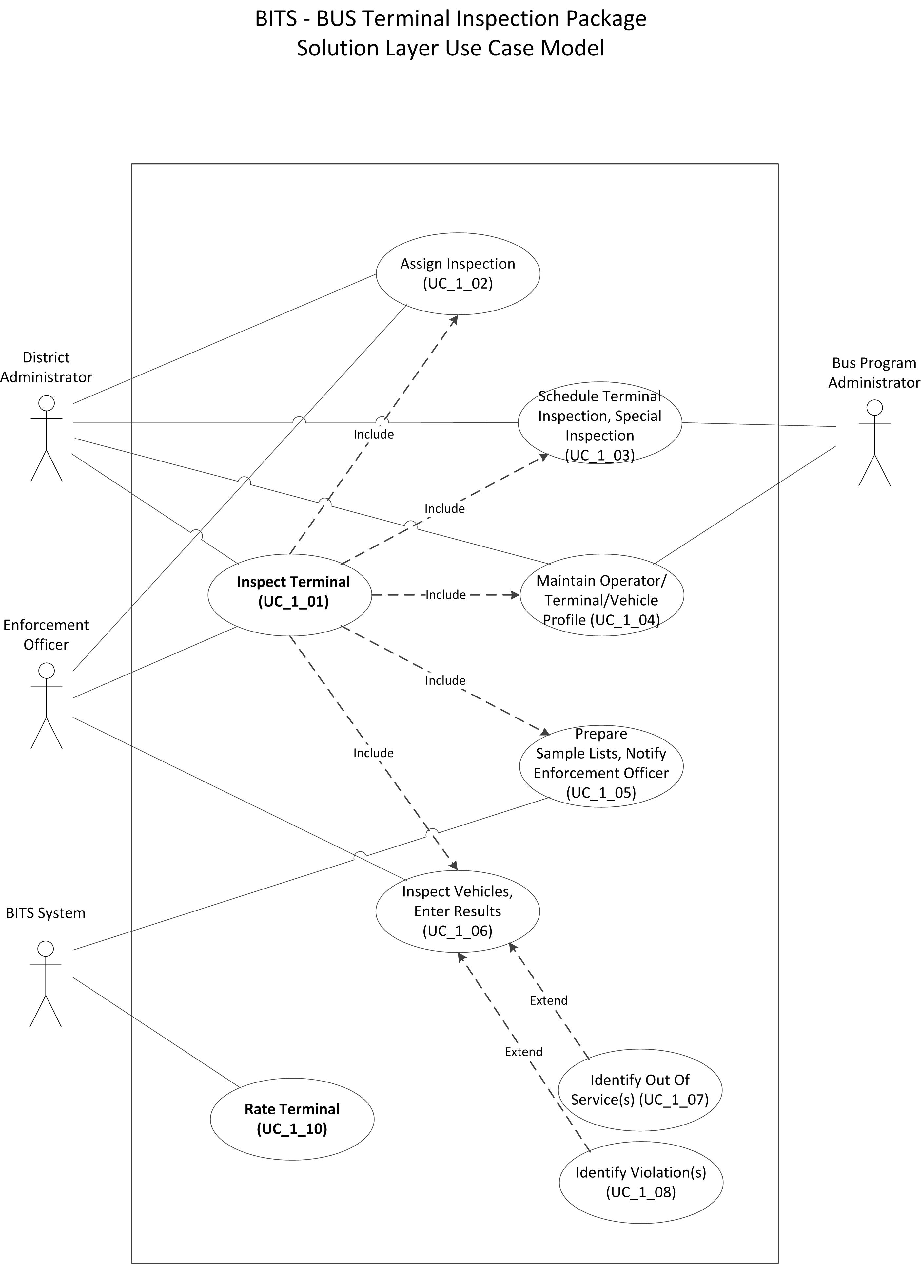

Bus Program Administration & Evaluation Package

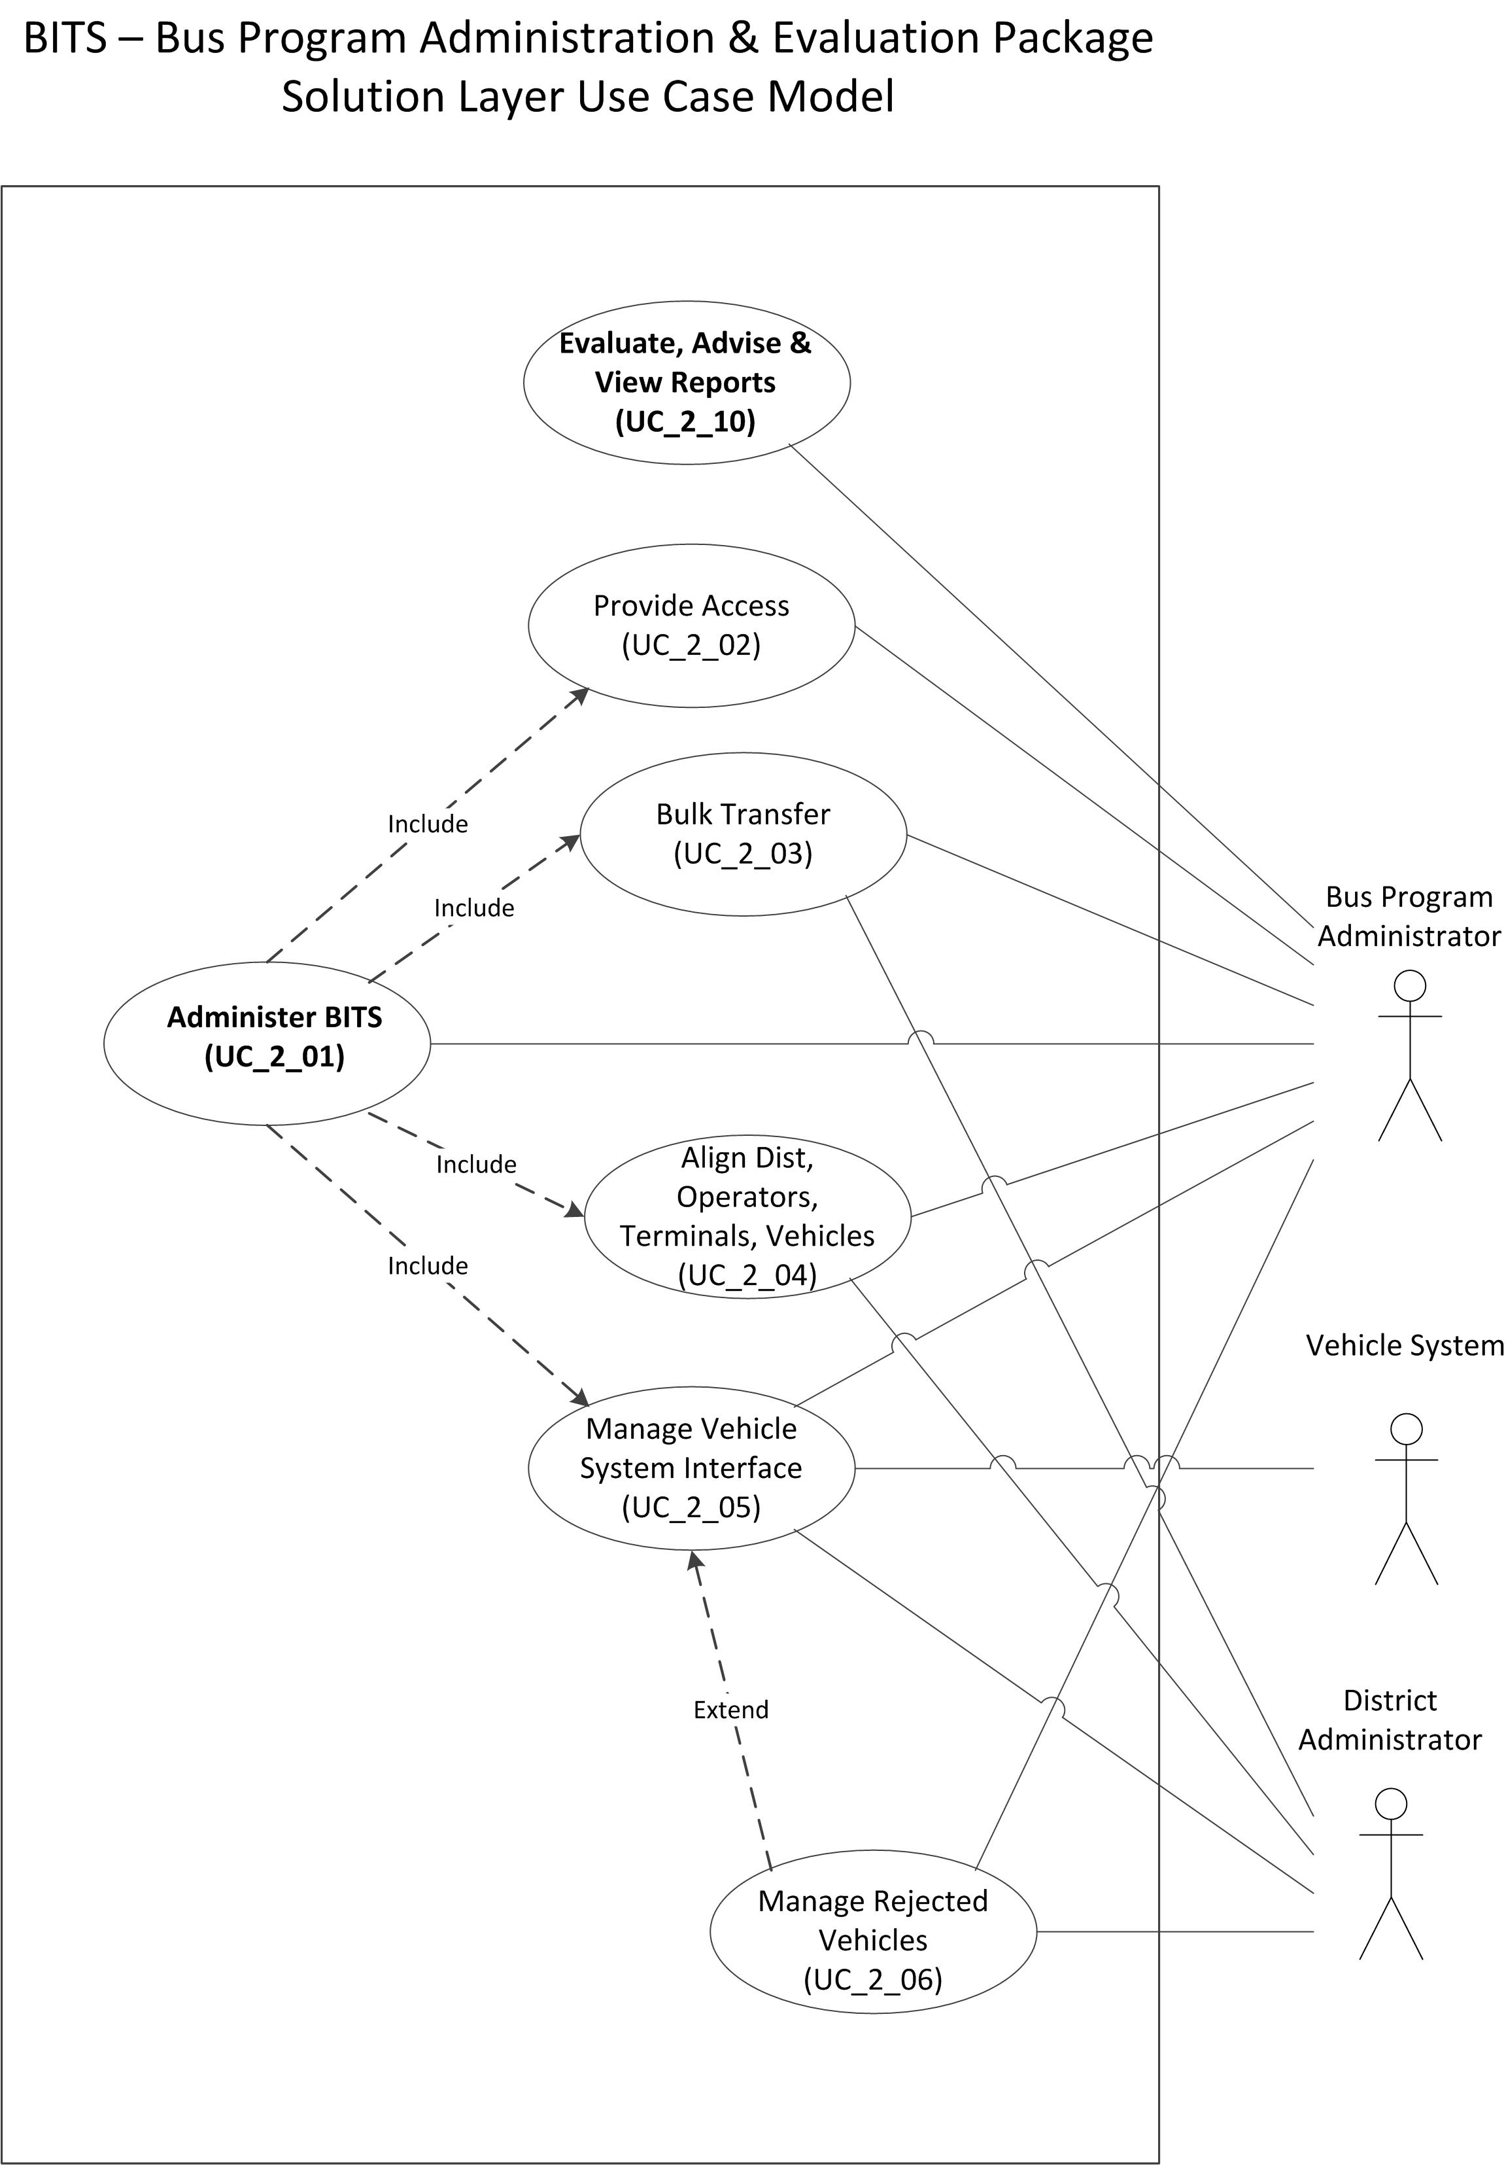

Use Case List

Code | Name | Description
UC_1_01 | Inspect Terminal | Terminal Inspection is scheduled based on Terminal classification (rating) and it could be A – every year, B – every 4 months, C – every month. A sample size of all vehicles based on a pre-set table is selected and the system shall provide the enforcement officers with the list of specific vehicles to comprise the required sample size. A summary of result is then entered into the system.
UC_1_02 | Assign Inspection | District Administrator assigned scheduled inspections to Enforcement Officers in the district and they have 3 months to perform the inspection before it becomes overdue. (Wireframe2) Note: The 3 month timeframe is under review.
UC_1_03 | Schedule Terminal Inspection, Special Inspection | The system sets the date of regular inspection automatically based on description on UC_1_01. Special inspection on the other hand are usually recommended by enforcement officers and scheduled and assigned manually by district administrator.
UC_1_04 | Maintain Operator/Terminal/Vehicle Profile | Add/Edit/Remove the three entities can be done by District Administrator (Wireframe1).
UC_1_05 | Prepare Sample Lists, Notify Enforcement Officer | The system selects a sample size and then two lists of candidate vehicles that comprise that size, one for vehicles older than 5 years old and second for those younger than 5 years. Enforcement Officers then go to a terminal with a clear purpose of which vehicles to inspect.
UC_1_06 | Inspect Vehicles, Enter Results | In a terminal, enforcement officers then inspect vehicles based on the lists provided in UC_1_05 and enter three items from the result for each vehicle into the system. (Wireframe3).
UC_1_07 | Identify Out of Service Vehicle(s) | As per UC_1_06, inspection result for each vehicle includes the fact that if it is Out Of Service (OOS).
UC_1_08 | Identify Violation(s) | As per UC_1_06, inspection result for each vehicle includes the number of its violations if there is any.
UC_1_10 | Rate Terminal | The system Rate each terminal as A, B or C based on the policy of: If there is any OOS vehicles, the Terminal gets C rate, otherwise: Category A> When the terminal fleet sample size is free of vehicle and driver violations (Monitored/assessed once every twelve months). Category B> When the terminal fleet sample size has one or more vehicle and/or driver violations and NO “Major Violations”, assessed every four months. Category C> When the terminal fleet sample size has one or more vehicle and/or driver “Major Violations”.  • Subsequent monitoring/reassessment will be one (1) month after the “C” rating is assigned.  A terminal can be immediately downgrade into “C” rating but upgrade is step by step, e.g. it cannot go from C to A. They would progress from C --> B if their inspection is free of Major(OOS) Violations. They could then proceed from B --> A on the next inspection if they are entirely violation free. (OK)
UC_2_01 | Administer BITS | The overall task of application administration including access management, setup, bulk transfer, integration management with the vehicle system.
UC_2_02 | Provide Access | Only 3 categories of user access is needed: Full Access (A_3 & A_4), Normal Access (A_1) and Limited Access (A_2).
UC_2_03 | Bulk Operation | Altering the header information such as Operator/CVOR, Terminal or districts for a bulk of detail records such as vehicle require a screen whereby users can select a group of records and change the associated attributes for all of them at once. (Wireframe4)
UC_2_04 | Align District, Operators, Terminal & Vehicles | Moving vehicles between terminals or terminals between the operators.
UC_2_05 | Manage Vehicle System Interface | LCS Vehicle System will have a daily interface into BITS, hence the logfile, accepted and rejected records will all need to be looked at and verified.
UC_2_06 | Manage Rejected Vehicles | Rejected vehicles from daily vehicle interface should not come back in the future, however, the administrator will have the chance to maintain the rejected list, adding or dropping vehicles from it.
UC_2_10 | Evaluate, Advise & View Reports | Managing reports is responsibility of the two actors in headquarter namely Head Enforcement and Bus Program Administrator.

Interface to Vehicle System

# | Requirement | Description
1 | Vehicle Interface | The daily system shall transfer all "Bus" vehicles that their VIN# is not already in BITS; Only Actively Plated vehicles should be included.
2 | Vehicle Interface - Add New Vehicles | Daily New Vehicle records shall be added to BITS immediately, new vehicle brings along with it VIN#, parent RIN and other information fields such as Colour, Make, Model, Valtag Expiry, etc. (see interface detail). If CVOR has only one Terminal then the vehicle is automatically assigned to its Terminal, otherwise it sits some parking lot for the District(s) administrator to determine which terminal they belong to. (District Admin for where the Operator HQ is will decide.)
3 | Vehicle Interface - Add New Vehicles - No Parent RIN | In case a New Bus Vehicle is transferred with no Existing Parent RIN in BITS, then the corresponding CVOR shall also be transferred into BITS (Manually or by system interface).
4 | Vehicle Interface - Change Vehicle Info | The system shall transfer all changes to the list of Vehicles already part of BITS. VIN is the unique identifier for Vehicle. Changes include plate#, Valtag Expiry date etc. No manual control/verification is required, nor needs a history of change to be kept.
5 | Vehicle Interface – Rejected Vehicle List | All incoming new vehicles will be checked by their respective District Administrator and if a record happens to be not a valid one for BITS system, it will be places in the “Rejected List”. As long as a vehicle is listed as Rejected it will not be brought into BITS through vehicle interface.

Wireframes

Profile Maintenance

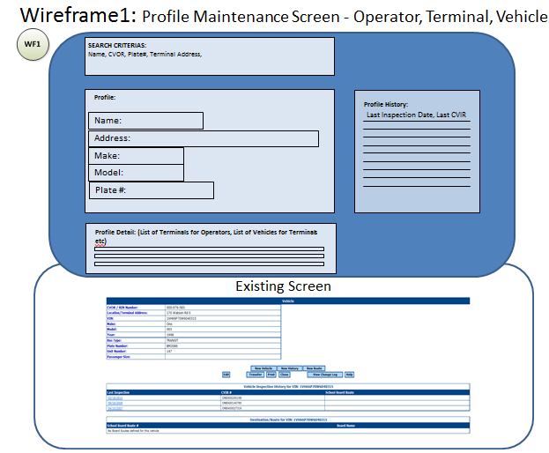

Inspection Assignment List
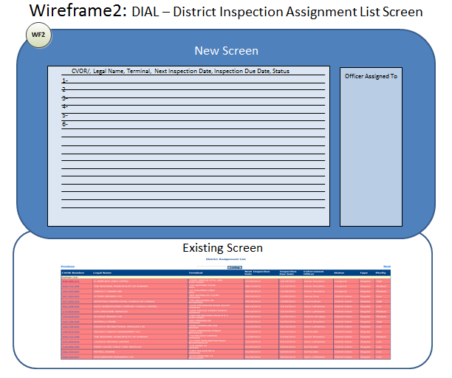

Inspection Notification and Results
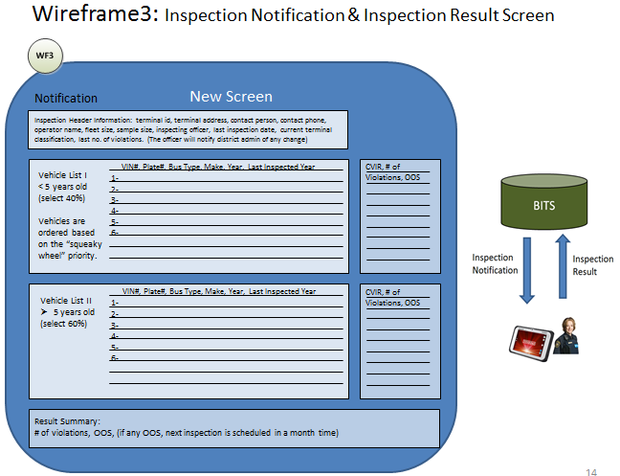

Bulk Operation
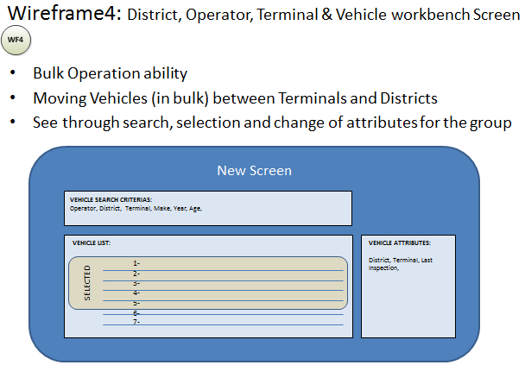

Security Requirements

Access Control

The two person Actors: Bus Program Admin has the right to add, delete or edit users.

Each District Administrator has access to assign inspection of his/her own district and full access to view and edit Operators, Terminals and Vehicles province wide.

Each Enforcement Officer will have viewing access to his/her own assignments and can enter the result of that inspection.

